***NEWSLETTER from the VERENIGING DE HEREENIGING***

***June 2019***

Dear Members and interested parties,

We would like to inform you of the latest news. To start with the most recent:

**Stayokay**

In April 2018 de city council published the “request for an all in one permit for a development plan for Zandpad 5” Stadsdeel west 18 April 2018

**Zandpad 5, 1054 GA**: changing the development plan from hostel to hostel with catering **OLO 3604361.**

This is a notification. At a later date you can submit your view point or objection. In a normal procedure you have 6 weeks to submit a written objection.”

The street commission took immediate action and a there were regular meetings with various members of the commission. A potentially undesirable situation was evolving for the inhabitants of the Roemer Visscherstraat and nearby streets. The permit applied for by the Stayokay (which now has 540 beds) would mean that the Stayokay guests and also the general public could use their catering facilities (the name they wanted to use for the catering facilities was The 5th). Stayokay have already opened this same sort of construction in Utrecht and Amsterdam East.

For a comparison, the Mariott hotel on the Stadhouderskade has 445 rooms,

This is the advert which was posted on the 5th:

“Eat and drink in the Amsterdam Vondelpark. Come to The 5th, our new lounge, restaurant and bar. Enjoy fun activities and events and food and drinks of course. All this in the Vondelpark – can it get any better?”

This initiative would definitely lead to a large influx of people in and around the Stayokay, especially in the garden which would cause disturbances for the people whose house are in the vicinity of this area. The increase in business and services would lead to the increase in need for supplies which would cause many transport problems for the small street Het Zandpad where lorries would not be able to get past each other. There is a gentlemen’s agreement to keep the doors of the Stayokay on the Roemer Visscherstraat closed and not use them as an entrance. With the new planned developments their need to use this entrance for deliveries would greatly increase. After a few street meetings it was decided to engage a solicitor to submit an objection to the plans. This led to a meeting with the objections commission from the council of Amsterdam, Stayokay representatives and objecting parties chaired by Mr V. Van Toledo.

**The council accepted our objection on 26th February 2019.**

The result is that the application has been rejected. It has also been decided that the council will pay 1,024 euro towards the costs of our complaint – this is a tenth of the total amount spent. This amount is welcome in the street commission bank account which is now standing at 750 euro.

To justify the decision on the objection, the council referred to the advice of the Objections Committee. In short, that committee ruled that:

1. a permit is not required for the use of a separate entrance in the former Amsterdamsche Huishoudschool because that entrance may be used for the "catering-sleeping" destination, but

2. it appears that Stichting Stayokay wants to operate an independent catering facility in the restaurant section of the hostel and that this is not permitted on the basis of the current development plan and also not on the basis of future development plans. In the Committee's opinion, in view of the interests of the parties objecting, no license can be granted to deviate from the development plan and to allow independent catering establishments via that link.

We are of course very pleased with the result.

We were able to cover the cost from very generous contributions form various members and interested parties living on both sides of the street.

Unfortunately, the case is not yet settled, as Stayokay has appealed to the Amsterdam court against the decision of the council.

The Stayokay stands opposite the council. The Court has written to all those involved who had joined in the first proceedings whether we, as a party, wish to participate in the appeal proceedings. It was decided by those directly involved that the same law firm would collectively notify all those involved at the time

**Automated street barrier pole (Vezip)**

Everyone is now familiar with the automatic street barrier pole at the entrance of the street which was installed in September 2017. After a few startup problems it is now functioning well. It has reduced the amount of traffic in the street at night and as a consequence there are also more available parking places. It has also reduced the disturbance in the street which was caused by people coming to pick their car up in the early hours of the morning after a late night out.

The original impetus for the protests was the (implemented) plans to move the taxi stand from Leidseplein to Leidsebosje.

There was the danger of increased traffic from taxis who wanted to make a short cut without traffic lights through the Roemer Visscherstraat from the Stadhouderskade to the South or further West.

The fear certainly also due to the fact that taxis waiting at this location, have to make an immediate loop on departure as traffic towards Leidseplein is no longer permitted.

That loop leads back to the Stadhouderskade.

The taxi rank has been functioning now for some time.

We do not have an overview to comments if there is sufficient control over the agreement that only taxis that run on gas or electrically are allowed to operate there.

Here too, the street commission was the driver and executor up to and including the high commission.

We have checked and it has been confirmed that all emergency services can operate the automatic pole remotely.

**Tree of the Year election.**

Plane (platanus family Platanaceae)) trees near Leidsebosje compete for 'Tree of the Year'

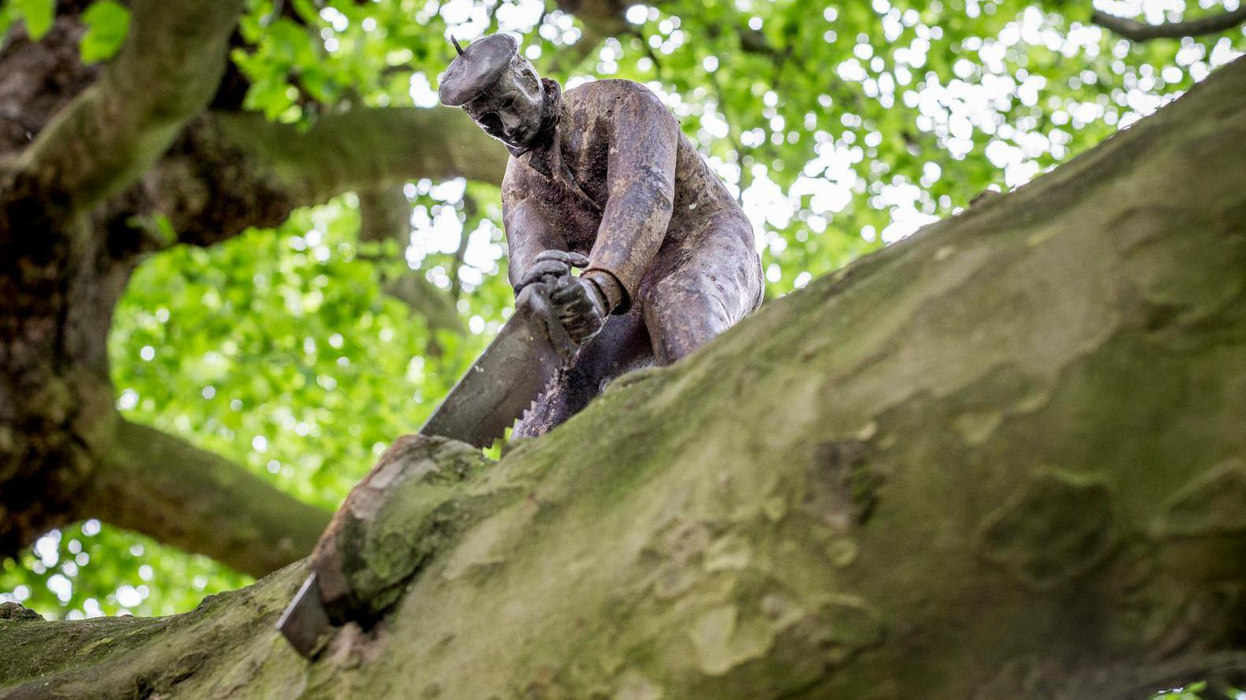

With almost seven meters in circumference, they are the thickest trees in Amsterdam: the two plane trees that were planted in 1862 in the Leidsebosje were competing for the title Tree of the Year.

The special story of the trees, which are included in the list of monumental trees of the Tree Foundation, was the reason for the council to nominate them for the national Tree of the Year election.

The procedure is that all twelve provinces of the Netherlands nominate their most special tree which can be voted for. This is not about the 'largest, oldest or most beautiful tree', the press release reports, but about trees 'with a story'. The winning tree then participates in the European Tree of the Year election.

Resistance

The plane trees in Leidsebosje also have a glorious history. When the bridge over the Singelgracht was widened in 1925 it was decided that the trees had to be cut down. This met with great resistance from the people of Amsterdam. This resulted in the plane trees (which were already sixty years old at that time) not being cut down but being moved fourteen meters away which was a unique occurrence at the time. The total costs of this operation at the time amounted to 1,255,000 guilders.

There is a statue on one of the plane trees– the tree cutter, which was placed in 1989 by an anonymous artist, who became known as The Unknown Sculptor.

Unfortunately, the plane trees did not win the competition – it was won by the oak on the central reservation of the A58.

**Building and renovating Amsterdam West and South**

Amsterdam is going to do something about the inconvenience of renovating buildings. In recent years, existing houses have been rebuilt more than before, ranging from an extension in inner gardens to the construction of additional floors, basements and balconies. The inconvenience is particularly great in the West and South boroughs. The council have drawn up a list of eighteen possible measures.

Many owners try to add as many square meters as possible to their home. Residents of the nineteenth-century neighborhoods in West and South have a lot of inconvenience due to dust and noise when the neighbours start renovating. The public space is also often subject to a long-term burden because there are construction containers, rubble bins and mobile toilets.

The digging of cellars can lead to groundwater problems. In more and more gardens, there is more stone than greenery, putting further pressure on the already scarce green space in the city.

The eighteen measures that the municipality is investigating concern, among other things, the adaptation of development plans and the permit policy, but also better communication with the residents of building projects. For example, restrictions on the possibility of building in the garden, or higher parking fees for construction-related vehicles. There must also be a building dynamics coordinator who will communicate between the project teams in the city districts.

Publication Municipality of Amsterdam:

**Renovate house? Nice, but there are limits**

February 13, 2019

An extra floor on the house, or a cellar underneath, maybe expanding in the inner garden ... the more square meters, the more a house is worth. Nice for the owner of the property, but not for the area. We must improve the balance in the city.

In recent years there have been many more renovations to existing buildings than before. We call this development building dynamics or building rage.

**Dust and noise**

Major renovations are taking place, especially in the 19th century neighborhoods in West and South. The residents experience a lot of inconvenience due to dust and noise and the public space is taken up by construction containers, rubble bins and mobile toilets.

**Green loses out to the stones**

The consequences go beyond that. If many gardens are paved, it is difficult for rainwater to drain, and the stones retain the heat for longer. That makes us less able to cope with heavy rain and hot summers. If everyone makes a basement under his house, groundwater problems can arise.

This must change

We must therefore intervene to counteract the negative consequences of this building rage. The Municipal Executive of B and W has drawn up a list of 18 possible measures together with the boroughs. They are now being tested for feasibility. Options are adjusting development plans, adjusting the permit policy and improving communication about building projects to local residents.

**Do not expand without a permit**

We are investigating whether in the development plans for De Pijp, Oud West, Museum Quarter / Valeriusbuurt, Hoofddorpplein / Schinkelbuurt and Westerpark we can include that it is not allowed to expand in the back garden without a permit. A limitation is already in force in De Pijp: instead of the legally determined 4 meters, you can expand there (with an environmental permit and under certain conditions) to a maximum of 2.5 meters.

We are also looking into whether we can add measures to the permits policy of the city districts to ensure, among other things, that the neighbourhoods remain climate-proof.

Higher parking rates for construction vehicles

To combat the inconvenience in the public space, the Commission is investigating whether higher parking rates may apply for construction vehicles. A pilot has now been started in the West district where it is mandatory to install a building board. It must state how long the work will take, the contact details and how many objects will be placed. You must now also have a permit to place objects.

**Shared bicycles and scooters**

“The Commission has recently adopted the shared mobility bill. With this, the shared bicycle scheme returns to the city on a small scale.

The next two years there is room for small-scale experiments with clean shared means of transport, such as shared bicycles and shared scooters.

In addition, two companies have been granted a city-wide permit for the provision of electric mopeds.

Through this method, more experience can be gained with sharing mobility. The results of the experiments determine the space that shared vehicles will have in the city after 2021.

The new policy covers all possible forms of shared mobility outside car sharing and offers the opportunity to learn about how the newest generation of electric mopeds and other means of transport contribute to the accessibility and quality of life in the city. "

Decision making policy on sharing mobility

This broad policy for sharing mobility follows the earlier policy memorandum for sharing bicycles that was entered into last year.

A total of 450 responses were received. The commission has adjusted the policy in response to these reactions and the coalition agreement.

An explanation of the responses and the adjustments are included in the Answering Note.

The documents will be discussed on 18 April in the Mobility, Air Quality and Sustainability Council.

The policy is then presented to the city council in May.

If the council also takes a positive decision, implementation can start.

You can download the invoices via the links below

[Download hier de volledige nota deelmobiliteit](https://assets.amsterdam.nl/publish/pages/905273/nota_deelvoertuigenbeleid.pdf)

[Download hier de Nota van Beantwoording](https://assets.amsterdam.nl/publish/pages/905273/nota_van_beantwoording_deelvoertuigenbeleid.pdf)

The street commission was one of the initiators of a response. The new policy was discussed in Het Parool:

<https://www.parool.nl/amsterdam/deelfietsen-nee-amsterdam-zet-in-op-de-deelscooter~a4624810/>

**Paid parking**

For those of you who have not noticed yet, paid parking has also been introduced on Sundays,

The normal rates apply from noon to midnight.

A scheme is still possible for visitors via a so-called Visitor's permit. Visitors can then park for a maximum of 10 hours per month for half the standard rate.

An informal care permit can also be applied for.

<https://www.amsterdam.nl/veelgevraagd/?productid=%7B29C84935-0712-4095-9F5E-36D91622694F%7D>

Practical for visitors is the initiative of [www.parkbee.com/nl](http://www.parkbee.com/nl)

Parking in the parking garage of the AOC in the parking garage of the AOC (2e Constantijn Huygensstraat 4). Prices from 2.50 per hour to a maximum of € 21 per 24 hours.

**Waste hotspots**

The council message:

“Every Amsterdammer knows containers that often have rubbish dumped next to them rather than in them, or places where rubbish bags are dumped on the street when there is no collection on those days. We call these places waste hotspots.

70% of this waste consists of mixed, mainly small, bulky waste, followed by 14% paper and cardboard. Rubbish bags occupy no more than 7%. An approach was drawn up in 2016 to reduce and prevent these hotspots.

In 2017, 158 of the 252 locations were reduced to the "under control " level.

**Collaboration**

We will continue with this approach based on the experience gained. The starting point is working together with residents and entrepreneurs.

Do you want to do something? Then adopt a container. Many people have already adopted an underground waste container. They keep the container and the surrounding area clean. This discourages others from placing waste next to the containers. And it appears to work. "

The entrance to the Roemer Visscherstraat has addition checks.

**New members and interested parties.**

The Board has welcomed a number of new members and interested parties. A summer drinks party will be arranged soon so that we can get to know each other better. Details of the date and location will follow shorty.

**SNS Bank**

The Board has been able to open a business account.

Outstanding contributions can be paid to:

De Hereeniging SNS Business account NL90 SNSB 0776 5277 70

The address of the Vereniging de Hereeniging is still Roemer Visscherstraat 21 2.